**Labaratory Work 2**

**Student:** Adil Zhexenov

**Group:** SE-2101

1) How many customers males and females? Show in percentage of Males and Females

among all records.



2) Get top 5 customers who most satisfied by store.

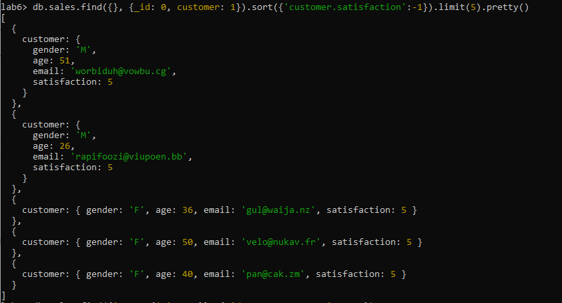

3) How many costumers bought only one item type (any quantity ) from the store. How

many of the males and females?

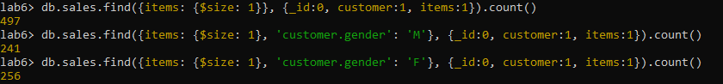

4) How many costumers bought only one item type (where quantity is one) from the

store. How many of the males and females?

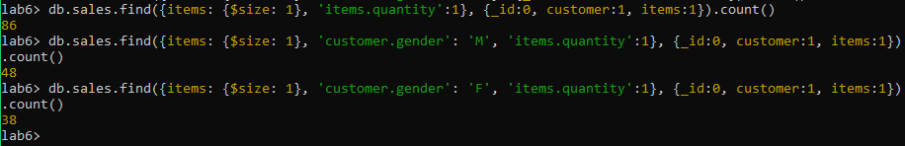

5) What is the average age of customer where satisfaction is 1?

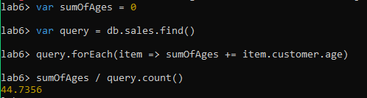

6) How much money spend ‘pan@cak.zm’? Note about quantity!!!

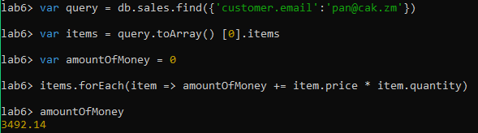

7) What is the average age of males and females!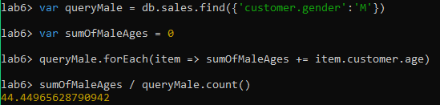

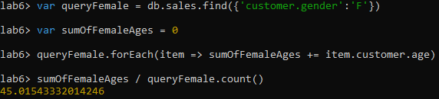

8) What is the average money spend by males and females?

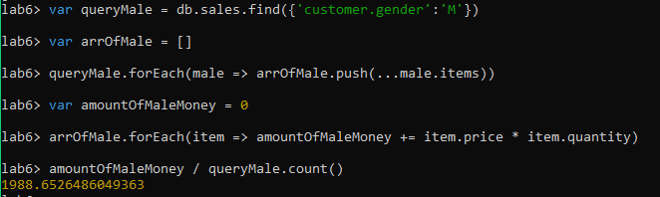

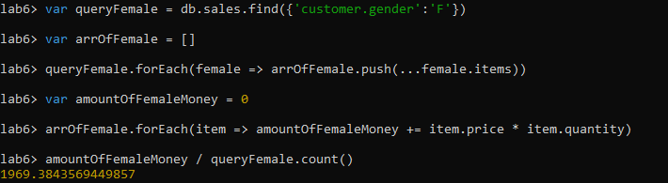

9) What is the average money spend by using coupon? What average without? How

many males and females used coupon?

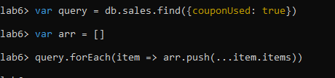

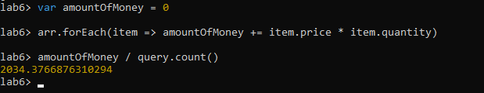

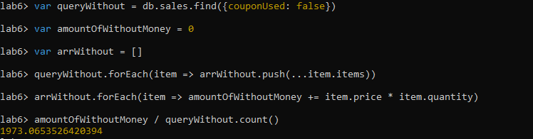

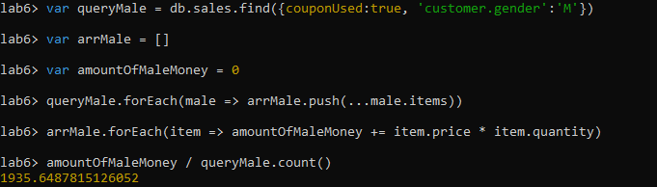

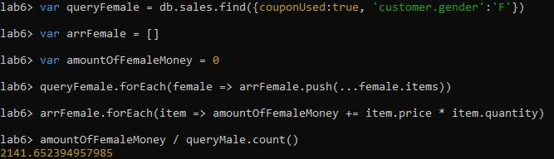

10) What is the average satisfaction where purchaseMethod online and for not online

